Installation

# WinPcap (WinPcap_4_1_2.exe)

If this is the first time you install the program on your computer, you have to install the WinPcap first. Otherwise you can just skip this step.

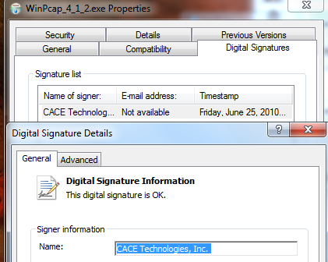

If you got this Installer files from Internet or somewhere else, you may need to check the Digital Signature of the install file.

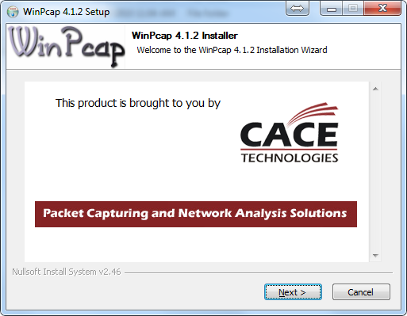

# DHR Matching Client (DHR Matching Client.msi)

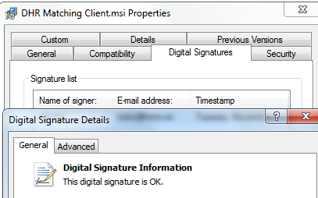

If you got this Installer files from Internet or somewhere else, you may need to check the Digital Signature of the install file.

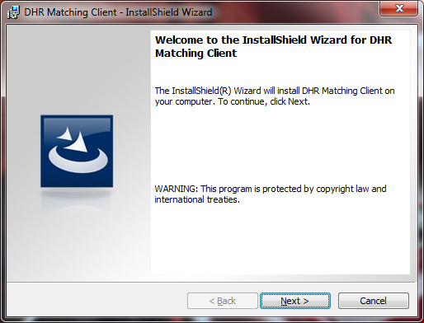

Click <**Next**> and finish the installation.

# Start DHR Matching Client

## How to Start?

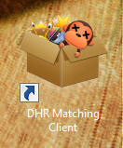

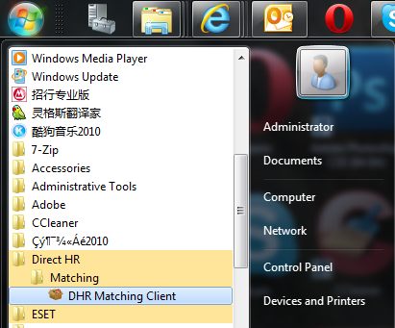

You can find the “DHR Matching Client” on your **Desktop** or in **Start Menu**.

## Network Adapter:

If there have multi-Network Adapter in your computer, you need to select the connected to the Internet one.

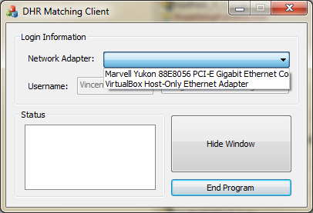

Then you may need to input the username into DHR Matching Client.

Username can be “Vincent Qiu” or “v.qiu”.

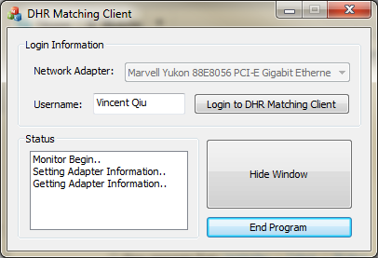

## Program working…

### The Icon…

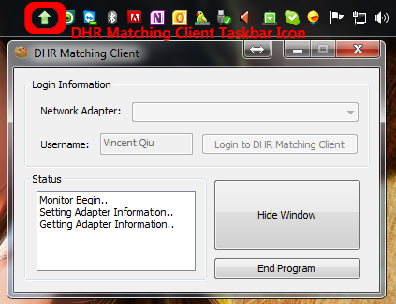

### Data Uploaded…

Once you search the resume on 51Job, China HR and ZhaoPin.Com websites, the icon in the taskbar will be changed.



And if the data failed to upload, the icon will be looks like below.

